Oscar Zaldana

Tetris Project

**Group:**

For the group project we will be making the game Tetris. We will be basing requirements on the Tetris wiki official guidelines.

Write-up/documentation:

Documentation of the current product will be attached on a separate folder.

So far we have implemented a pause key, line deletion, block drop down after line deletion, a canvas for game matrix, borders for block restraints, collision detection, block rotation, bit push back when rotation occurs on a collision, scoring, Tetris scoring, block drop down, frame rate, soft fast fall, hard fast fall, ghost block, t-spin, next blocks, block instantiation, music, block drop sound, level speed increase, game over screen and restart button.

Description/rules:

Tetris is a time-based puzzle game that increases speed based on the level of the player. The player will be given a block and it is the players task to combine the different pieces to make a horizontal line. Once a line is made the row will be eliminated and a score will be given based on how many lines are depleted. The most lines that ca be deleted is four also called a Tetris. The score is multiplied when a Tetris occurs and even more when a Tetris is in a row. The player only has a 12X20 set of space to work with and when the blocks reach the very top the player loses. In order to have this game include certain semester topics the game will include a leader board and an administrator log in so that cookies, and other web enhanced code can be utilized.

Flow chart:

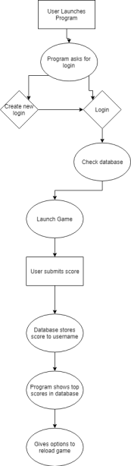

Uml:

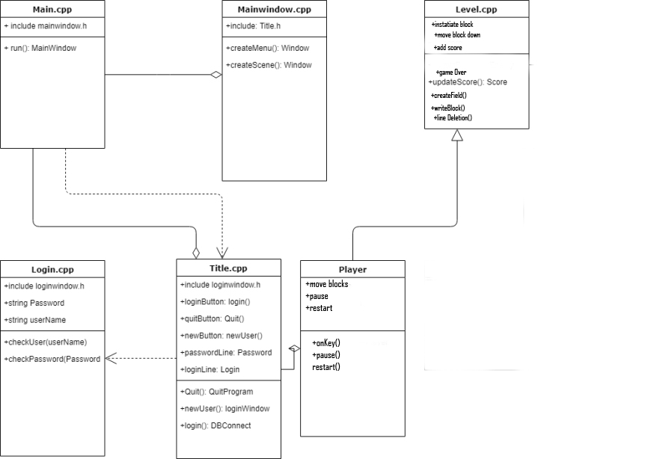

Midterm vs final:

The main focus of the midterm was to get a fully functioning game working. The biggest difference between midterm and final will be that the final will have all the concepts applied, the code will be rewritten and organized to include a model view controller. Cookies, databases, login, form validation, regular expression, and client server will also be added to both the group and individual project. Along with a better a structured format the inclusion of better-looking assets will be included so that the game looks more like Tetris. We also hope to add some animations for aesthetic purposes.